Algorithmic Complexity and Correctness [25 points]
Task 1. [20 points]
b) Do an exact analysis of the running time of the algorithm.

Algo:
Input: array A[1..n] of length n, 1 ≤ k ≤ n
Output: print the maximum value of every contiguous
subarray of size k

findKMax(A, k, n) | Duration | Number of executions
for i = 1 to n − k + 1 do | c1 | (n-k+1)
max = A[i]; | c2 | (n-k+1)
for j = 1 to k − 1 do | c3 | (n-k+1)*(k-1)
if A[i + j] > max then | c4 | (n-k+1)*(k-1)
max = A[i + j]; | c5 | (n-k+1)*0..(k-1)
print(max) | c6 | (n-k+1)
Runtime:
T(n)=(c1+c2+c6)*(n-k+1)+(c3+c4)*(n-k+1)*(k-1)+c5*(n-k+1)*0..(k-1)

c) Determine the best and the worst case of the algorithm. What is the
running time and asymptotic complexity in each case?
(n-k+1)*(k-1)= n*k+2*k-n-k^2-1
Best case:
Running time: T(n)=(c1+c2+c6)*(n-k+1)+(c3+c4)*(n-k+1)*(k-1)
Asymptotic complexity: T(n)=O(n*k - k^2)
Worst case:
Running time: T(n)=(c1+c2+c6)*(n-k+1)+(c3+c4+c5)*(n-k+1)*(k-1)
Asymptotic complexity: T(n)=O(n*k - k^2)
d) What influence has the parameter k on the asymptotic complexity?
If k and n of same order: T(n)=O(1)
If k<<n: T(n)=O(n)
Task 2. [5 points]
Given an unsorted array A[1..n] that contains only numbers 0, 1, and 2, the following algorithm rearranges the elements of A, such that all occurrences of 0 come before all occurrences of 1 and all occurrences of 1 come before all occurrences of 2.  State a loop invariant for the algorithm partitionValues and show that it is correct.  l is the iterator  k is the left border between 0 and 1  m is the right border between 1 and 2  Invariants:  (0) progression is guaranteed:  ->either l moves to the right or m to the left  (1) for all indices i < k: A[i]=0  (2) for all indices i >m: A[i]=2  Start:  (1) ok because i is out of bound  (2) ok because i is out of bound  Maintenance:  (1) ok because if statement is moving 0s to the left of k_new  (2) ok because else statement is moving 2s to the right of m_new  Termination:  (1) ok because at l=m last step is correct then stop  (2) ok because at l=m last step is correct then stop | 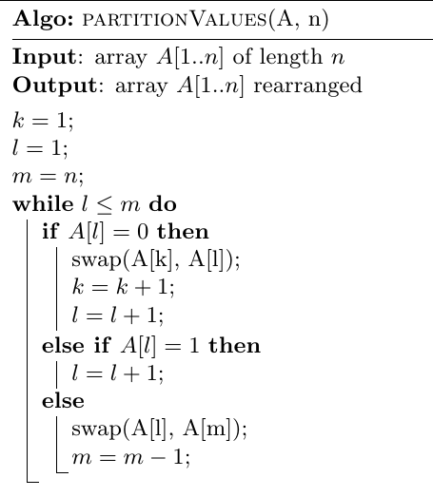

Asymptotic Complexity [3 points]
Task 3. [3 points]
Calculate the asymptotic tight bound for the following functions and rank them by their order of growth (lowest first). Clearly work out the calculation steps in your solution.
f1(n) = log(pi*n) + log(100^log(n) )  log(pi*n) + log(n)*log(100)  Theta(log(n)) | 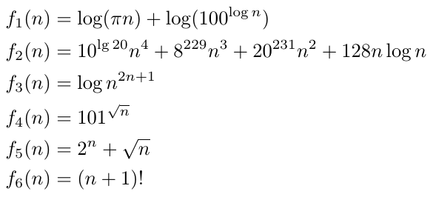
f2(n) = 10^(lg(20)) * n^4 + 8^229 * n^3 + 20^231 * n^2 + 128*n * log(n)
Theta(n^4)
f3(n) = log(n^(2n+1))
(2n+1)* log(n)
Theta(n*log(n))
f4(n) = 101^(n^0.5)
Theta(101^(n^0.5))
f5(n) = 2n + (n^0.5)
Theta(2^n)
f6(n) = (n + 1)!
Theta((n+1)!)

Ranking:
f1(n)<f3(n)<f2(n)<f4(n)<f5(n)<f6(n)
Special Case Analysis [15 points]
Task 4. [15 points]
Given two strings A and B, develop an algorithm that checks if B is a permutation of A. For example, if B = "aabb" and A = "baba", the return value will be TRUE. If B = "ab" and A = "baba", the return value will be FALSE.

a) Specify all the special cases that need to be considered and provide examples of the input data for each of them.

1.Size(A) = Size (B)
If e.g. A=[...] and B=[……..] then stop

2.Size(A) = Size (B) = 0
If A=[] and B=[] return true

3.Size(A) = Size (B) = 1
If A=[.] and B=[.] compare values and return

4.CharacerIn(A) = CharacterIn(B)
If A=[xaabbccaabbccaabbcc] and B=[aaabbccaabbccaabbcc] x not found in B then stop

5.CountOfCharacterIn(A) = CountOfCharacterIn(B)
If A=[aabbccaabbccaabbcc] and B=[aaabbccaabbccaabbcc] count occurrences and return

Recurrences [12 points]
Task 5. [6 points]
Recurrence
T (n)=1 if n = 1
T (n) =T (n/6) + T (n/2) + n if n > 1
a) Draw a recursion tree and use it to estimate the asymptotic upper bound of T (n). Include the tree-based calculations that led to your estimate. [3 points]

 | T(n/6) = T (n/36) + T (n/12) + n/6  T(n/2)= T (n/12) + T (n/4) + n/2  T (n/36) =T (n/216) + T (n/72) + n/36  T (n/12) =T (n/72) + T (n/24) + n/12  T (n/4) =T (n/24) + T (n/8) + n/4
   |  |  |  | n |  |  |  | n
   |  |  | n/6 | n/2 |  |  |  | n4/6
   |  | n/36 | n/12 | n/12 | n/4 |  |  | n16/36
  n/216 | n/72 | n/72 | n/24 | n/72 | n/24 | n/24 | n/8 | n64/216
T(n)=n+n*sum((4/6)^i, i=1..inf)
=n+n*(1/(1-4/6))
=4n
=O(n)
b) Prove the correctness of your estimate using the substitution method. [3 points]
Recurrence: T (n) =T (n/6) + T (n/2) + n
Guess: T(n)=O(n)
Show that: T(n)<=cn
T (n) =T (n/6) + T (n/2) + n<=cn/6+cn/2+n=4cn/6+n<=cn für c>=3

Task 6. [6 points] Calculate the asymptotic tight bound of the following recurrences. If the Master Theorem can be used, write down a, b, f (n) and the case (1-3).
1. a=3, b=9, f(n)=32*n^0.5=O(n^c) mit c=0.5  log9(3)=0.5  Case 2: T(n)=Theta(n^0.5 *log10(n)) | 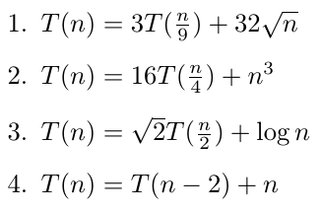
2. a=16, b=4, f(n)=n^3=O(n^c) mit c=3
log4(16)=2
Case 3: T(n)=Theta(n^3)
3. a=2^0.5, b=2, f(n)=log(n)=O(n^c) mit c=log10 (log10 (n))/log10 (n)
für n=1 Mio, c=0.129
log2(2^0.5)=0.5
Case 1: T(n)=Theta(n^0.5)
4. T(n)=T(n-6)+n-4+n-2+n
=T(n-2*i)+n*i-sum(-2*j, j=1,i-1), imax=(n-1)/2
=T(1)+n*(n-1)/2+?
=Theta(n^2)

Master Method:
Master Method is a direct way to get the solution. The master method works only for following type of recurrences or for recurrences that can be transformed to following type.
T(n) = aT(n/b) + f(n) where a >= 1 and b > 1
There are following three cases:
1. If f(n) = Θ(nc) where c < Logba then T(n) = Θ(nLogba)
2. If f(n) = Θ(nc) where c = Logba then T(n) = Θ(ncLog n)
3.If f(n) = Θ(nc) where c > Logba then T(n) = Θ(f(n))

